11、Infrared following

**Follow the steps to splice the building blocks ：**

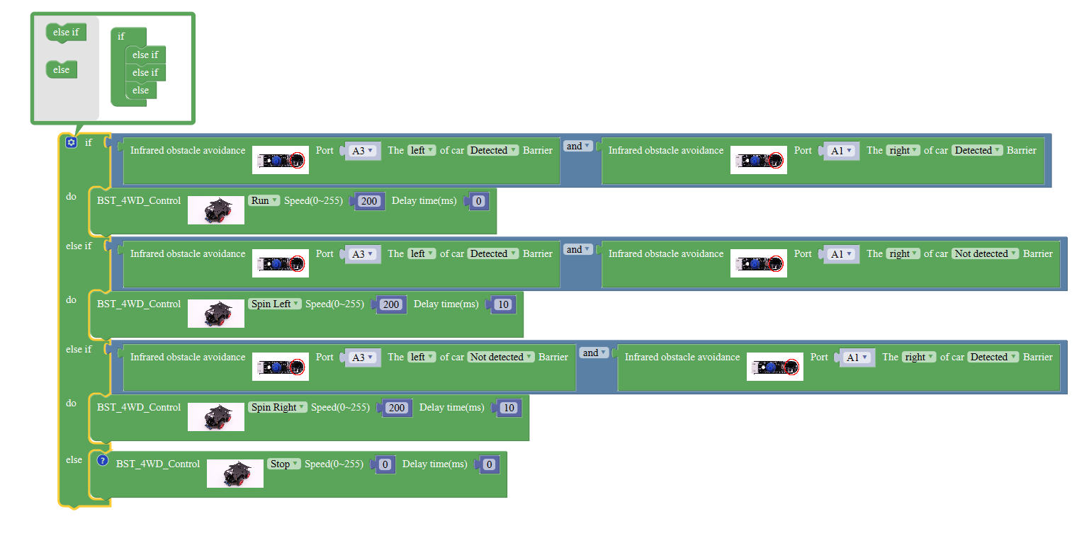

**1、Experimental building blocks :**

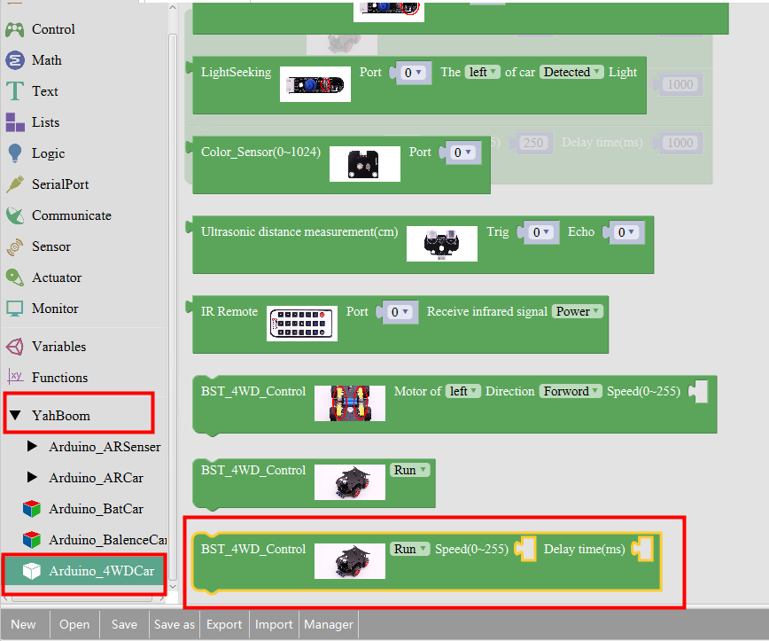

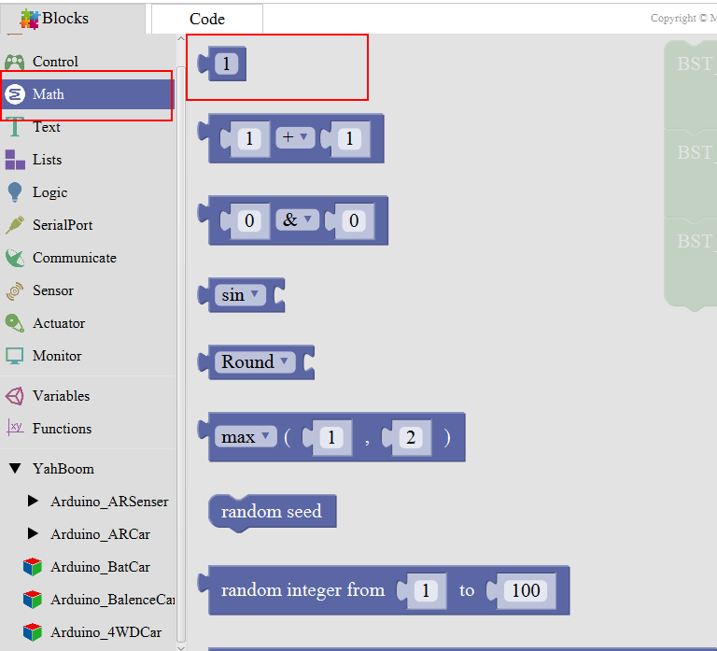

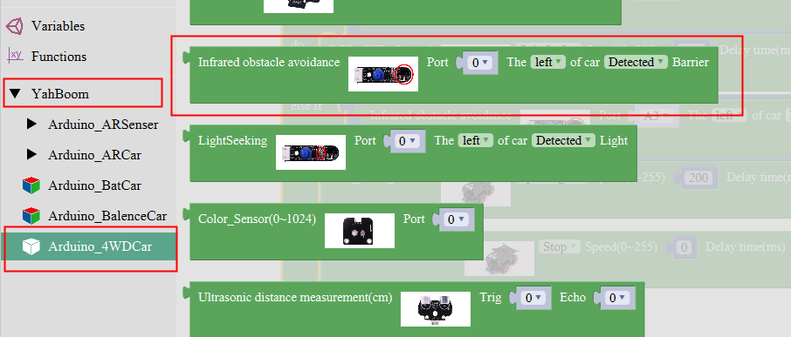

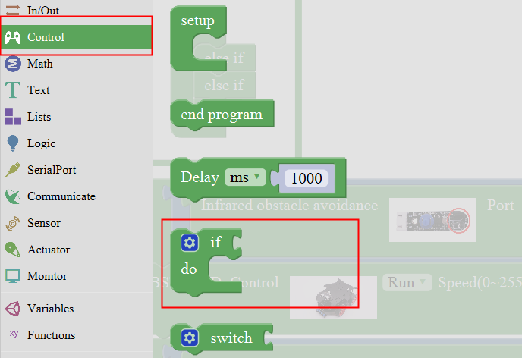

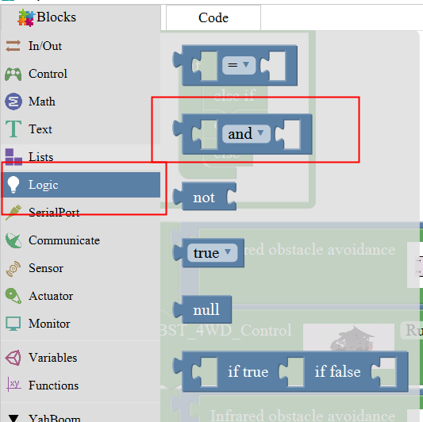

Note:

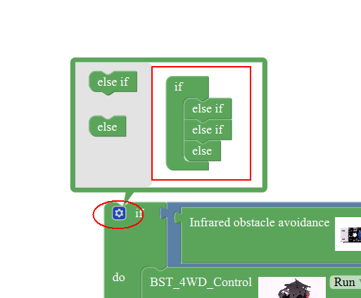

**2、Experimental verification：**

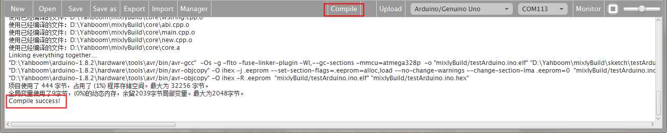

1. After splicing, select the compile button above the picture, wait for the completion of the compiler, the following box will prompt the compiler successfully, if prompt the compile failure is the problem of building block splicing.

b、After compiled , select **Arduino/Genuino Uno** follow the picture,

selects the serial number of the corresponding board.

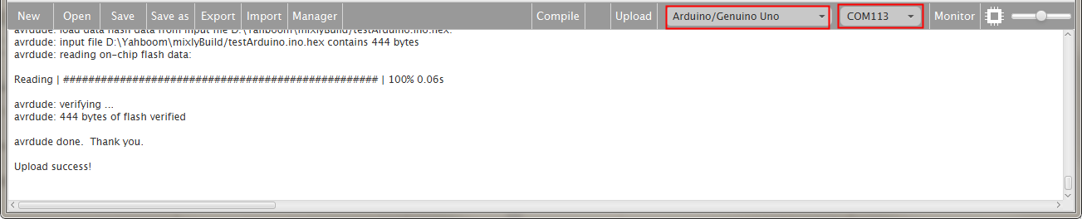

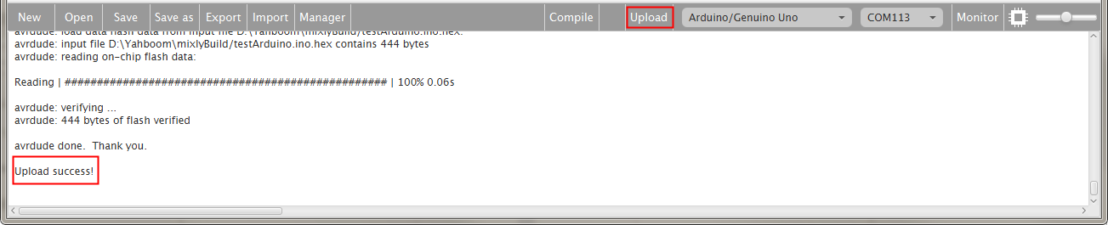

c、After configured,select the upload button above the picture, wait for the following box prompt the upload successfully. Debugging infrared probe, infrared obstacle avoidance can be regulated by rotating potentiometer sensitivity distance, and then adjust the distance according to the speed, thus preventing too quickly hit the car following, in the following areas, turn on the power, placed in front of the car to follow, to see whether the car with the obstacles ahead.